ASA LAB (THY DAYUTH) Group 1 Group 1

Topology
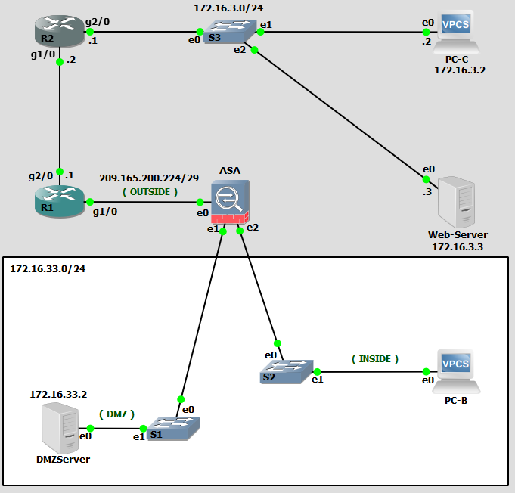
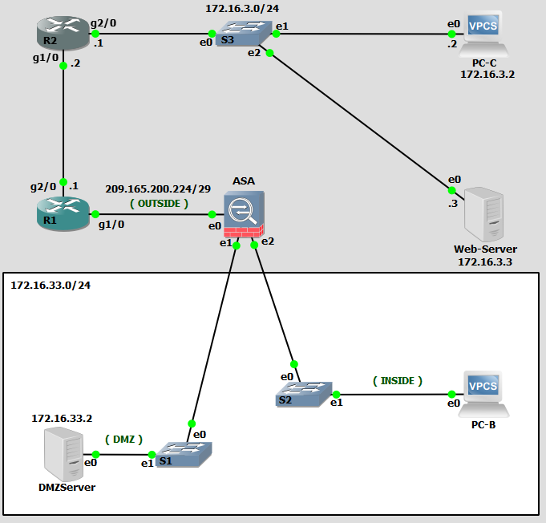

- Show Run
ciscoasa# show run
: Saved

:
: Serial Number: 9AL5BLSCCN6
: Hardware: ASAv, 2048 MB RAM, CPU Xeon 5500 series 2809 MHz
:
ASA Version 9.8(3)
!
hostname ciscoasa
enable password $sha512$5000$Vp7lLmpz+JbmGq2jg/z9ZQ==$Zy9UTVep05IBMhYJHamDdQ== pbkdf2
names
no mac-address auto

!
interface GigabitEthernet0/0
nameif outside
security-level 0
ip address 209.165.200.226 255.255.255.248
!
interface GigabitEthernet0/1
nameif dmz
security-level 50
ip address 172.16.33.1 255.255.255.128
!
interface GigabitEthernet0/2
nameif dmz
security-level 50
ip address 172.16.33.1 255.255.255.128
!
interface GigabitEthernet0/2
nameif inside
security-level 100
ip address 172.16.33.129 255.255.255.128
!
interface Management0/0
shutdown
no nameif
no security-level
no ip address
!
ftp mode passive
object network INSIDE_NET
subnet 172.16.33.128 255.255.255.128
object network DMZ_SERVER
host 172.16.33.2
access-list OUTSIDE_IN extended permit tcp any object DMZ_SERVER eq www
access-list OUTSIDE_IN extended permit icmp any any echo-reply
access-list OUTSIDE_IN extended permit icmp any any echo
pager lines 23
mtu outside 1500
mtu dmz 1500
mtu inside 1500
no failover
icmp unreachable rate-limit 1 burst-size 1
no asdm history enable
arp timeout 14400
no arp permit-nonconnected
arp rate-limit 8192
!
object network INSIDE_NET
nat (inside,outside) dynamic interface
object network DMZ_SERVER
nat (dmz,outside) static 209.165.200.227
access-group OUTSIDE_IN in interface outside
route outside 0.0.0.0 0.0.0.0 209.165.200.225 1
timeout xlate 3:00:00
timeout pat-xlate 0:00:30
timeout conn 1:00:00 half-closed 0:10:00 udp 0:02:00 sctp 0:02:00 icmp 0:00:02
timeout sunrpc 0:10:00 h323 0:05:00 h225 1:00:00 mgcp 0:05:00 mgcp-pat 0:05:00
timeout sip 0:30:00 sip_media 0:02:00 sip-invite 0:03:00 sip-disconnect 0:02:00
timeout sip-provisional-media 0:02:00 uauth 0:05:00 absolute
timeout tcp-proxy-reassembly 0:01:00
timeout floating-conn 0:00:00
timeout conn-holddown 0:00:15
timeout igp stale-route 0:01:10
user-identity default-domain LOCAL
aaa authentication login-history
no snmp-server location
no snmp-server contact
crypto ipsec security-association pmtu-aging infinite
crypto ca trustpoint _SmartCallHome_ServerCA
no validation-usage
crl configure
crypto ca trustpool policy
auto-import
telnet timeout 5
ssh stricthostkeycheck
ssh timeout 5
ssh key-exchange group dh-group1-sha1
console timeout 0
dhcpd dns 172.16.33.2
!
dhcpd address 172.16.33.135-172.16.33.150 inside
dhcpd enable inside
!
threat-detection basic-threat
threat-detection statistics access-list
no threat-detection statistics tcp-intercept
dynamic-access-policy-record DfltAccessPolicy
!
class-map inspection_default
match default-inspection-traffic
!
!
policy-map type inspect dns preset_dns_map
parameters
message-length maximum client auto
message-length maximum 512
no tcp-inspection
policy-map global_policy
class inspection_default
inspect ip-options
inspect netbios
inspect rtsp
inspect sunrpc
inspect tftp
inspect xdmcp
inspect dns preset_dns_map
inspect ftp
inspect h323 h225
inspect h323 ras
inspect rsh
inspect esmtp
inspect sqlnet
inspect sip
inspect skinny
inspect icmp
policy-map type inspect dns migrated_dns_map_2
parameters
message-length maximum client auto
message-length maximum 512
no tcp-inspection
policy-map type inspect dns migrated_dns_map_1
parameters
message-length maximum client auto
message-length maximum 512
no tcp-inspection
!
service-policy global_policy global
prompt hostname context
call-home reporting anonymous prompt 2
call-home
profile CiscoTAC-1
no active
destination address http https://tools.cisco.com/its/service/oddce/services/DDCEService
destination address email callhome@cisco.com
destination transport-method http
subscribe-to-alert-group diagnostic
subscribe-to-alert-group environment
subscribe-to-alert-group inventory periodic monthly
subscribe-to-alert-group configuration periodic monthly
subscribe-to-alert-group telemetry periodic daily
Cryptochecksum:388a298f3d330a436adb11b92f8511a2
: end
- Show Run SSH
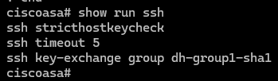
- Show route
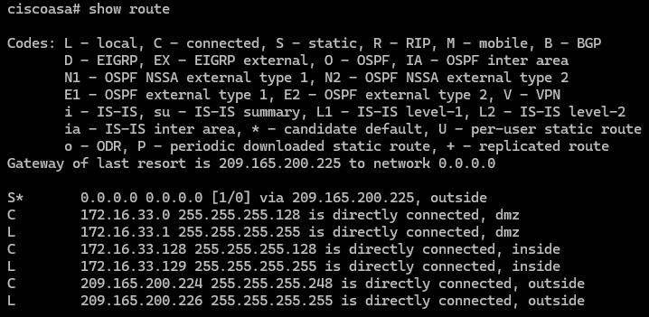
- Show nat
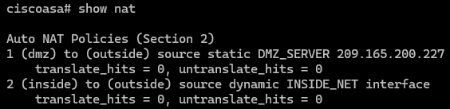
- Show xlate
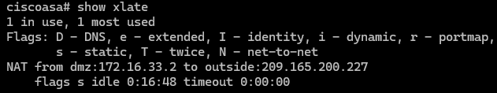
- Show access-list
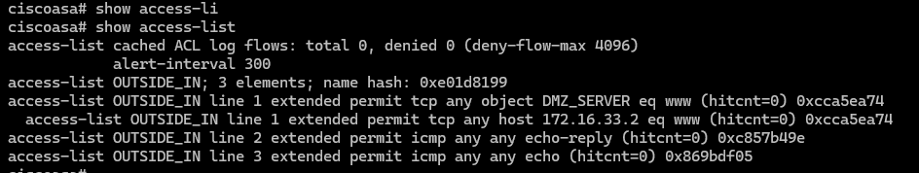
- Show run access-group
